ESP8266EX chip pinout is something like this:
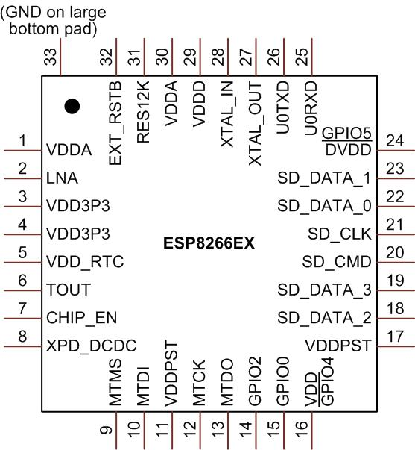
Pin | Name | Type | GPIO | Function
1 | VDDA | P |  | Analog Power (LNA) 3.0 ~ 3.3V
2 | LNA | I/O |  | 50 Ohm RF Output ; recommended to retain π-type matching network
3 | VDD3P3 | P |  | Power Amplifier (PA_BALUN) 3.0~3.3V
4 | VDD3P3 | P |  | Power Amplifier (PA_STG1) 3.0~3.3V
5 | VDD_RTC | P |  | NC (1.1V)
6 | TOUT | I |  | ADC pin
7 | CHIP_EN | I |  | Chip Enable – Active High /Chip Disable (very low power consumption) – Low
8 | XPD_DCDC | I/O | GPIO16 | Deep-Sleep Wakeup
9 | MTMS | I/O | GPIO14 | HSPICLK
10 | MTDI | I/O | GPIO12 | HSPIQ
11 | VDDPST | P |  | Digital and IO Power(1.8V~3.3V)
12 | MTCK | I/O | GPIO13 | HSPID
13 | MTDO | I/O | GPIO15 | HSPICS
14 | GPIO2 | I/O | GPIO2 | UART_Tx (when used to programm Flash)/UART1_TX(when used as debug output);
15 | GPIO0 | I/O | GPIO0 | SPICS2
16 | GPIO4 | I/O | GPIO4 | GPIO4
17 | VDDPST | P |  | Digital and IO power(1.8V~3.3V)
18 | SDIO_DATA_2 | I/O |  | SD_D2 (serial 200Ω)/SPIHD/HSPIHD
19 | SDIO_DATA_3 | I/O |  | SD_D3 (serial 200Ω)/SPIWP/ HSPIWP
20 | SDIO_CMD | I/O |  | SD_CMD(serial 200Ω)/ SPICS0
21 | SDIO_CLK | I/O |  | SD_CLK (serial 200Ω)/SPICLK
22 | SDIO_DATA_0 | I/O |  | SD_D0 (serial 200Ω)/SPIQ
23 | SDIO_DATA_1 | I/O |  | SD_D1 (serial 200Ω)/SPID
24 | GPIO5 | I/O | GPIO5 | GPIO5
25 | U0RXD | I/O | GPIO3 | UART_Rx(when used to program Flash)/UART0_RX(when used to receive data packet's)
26 | U0TXD | I/O | GPIO1 | UART0_TX(when used to receive data packet's)/SPICS1
27 | XTAL_OUT | I/O |  | Crystal output terminal
28 | XTAL_IN | I/O |  | Crystal input terminal
29 | VDDD | P |  | Analog Power (XTAL;PLL) 3.0~3.3V
30 | VDDA | P |  | Analog Power 3.0~3.3V
31 | RES12K | I |  | Serial 12kΩ resistor to ground
32 | EXT_RSTB | I |  | External reset signal (active low)

Note: GPIO2, GPIO0, MTDO can be configurable as 3-bit SDIO mode.

UART’s harware connection
UART | Pins | Description
UART0 | (PIN 25) U0RXD + (PIN 26) U0TXD | Communications (used to send and receive data packets)
UART1 | (PIN 14) GPIO2 (TXD) | Debug Print.

